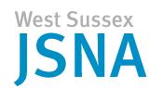
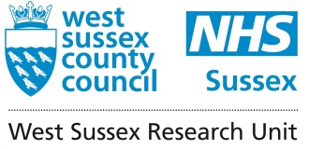

EQUALITY ACT 2010
PROTECTED CHARACTERISTICS

POPULATION LEVEL INFORMATION & SOURCES - UPDATE
MARCH 2013

Equality Act 2010 – BACKGROUND INFORMATION

In 2012, a report produced by West Sussex Research Unit provided estimates on the number of people covered by the Equality Act 2010.

The Act related to people defined under the following nine protected characteristics:-

- Age
- Sex
- Disability
- Race
- Religion and belief
- Gender re-assignment
- Marriage and civil partnership
- Sexual orientation
- Pregnancy and maternity

Under the Equality Act people are not allowed to discriminate, harass or victimise another person because they have any of the protected characteristics. The Act also requires the public sector bodies must have “due regard to the need to”:

- Eliminate unlawful discrimination, harassment and victimisation
- Advance equality of opportunity
- Foster good relations between different groups

The term “due regard” means that the body is required to consciously consider these aims when making decisions about policy or practice which would affect people; including:
- how a public authority acts as an employer
- how it develops policies
- how it designs and delivers services
- how it procures services.

Following on from that report, this document provides updated estimates of people covered by the protected characteristics based on recent reports and estimates released from the 2011 Census.

Protected Characteristics – AGE AND SEX

Resident Population – Updated Information from 2011 Census

Note: Office of National Statistics (ONS) produces annual estimates of population called Mid-Year Estimates (MYE). This together with the 2011 Census population estimates have been used to compare changes in the population over certain time periods.

- The population of West Sussex from the 2011 Census is estimated to be 806,900

- 20.2% of the population are 18 years and under, 59.2% of 18-64 years of age while 20.6% of the population are 65 years and over.

- This was an increase of approximately 7,200 people (0.9%) from the 2010 mid-year estimate.

- Over the last 10 years, the population of West Sussex has increased by 7%, which is similar to the UK overall change.

- Between 2010 and 2011, the population for Chichester, Horsham, Mid Sussex and Worthing has increased with Mid Sussex experiencing a 5.5% increase. Over the same time period, the population of Adur, Arun and Crawley decreased by 0.5%, 0.9% and 0.7% respectively.

- The number of older people continues to increase at a higher rate than the overall population. It is estimated that 168,100 people were aged 65 and over in 2011 (MYE 2011), a 1.3% increase from the 2010 estimate of 166,000.

Figure 1 Population Change between 2001 and 2011 Census at Ward level (%)
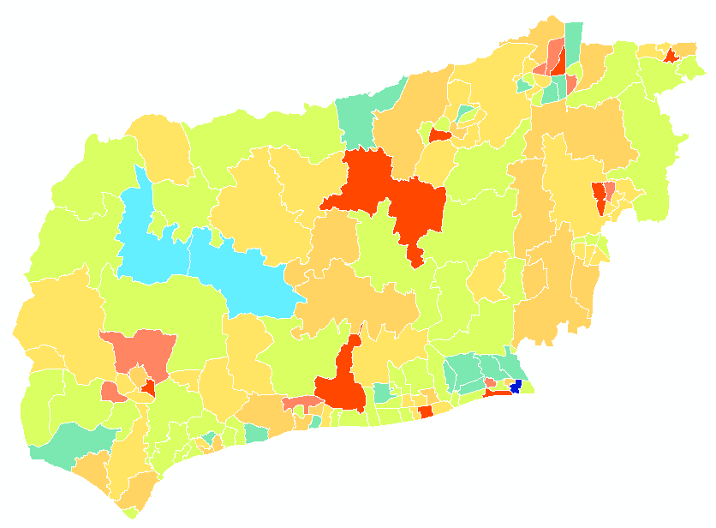
Source: ONS Census 2011 and Census 2001
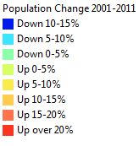

Table 1 Mid-Year Estimates of Population – 2007 to 2011
Note that figures may not add up due to rounding

 | West Sussex 2007 | West Sussex 2008 | West Sussex 2009 | West Sussex 2010 | West Sussex 2011
0 | 8,700 | 8,900 | 8,900 | 9,100 | 9,200
1-4 | 34,000 | 34,700 | 35,400 | 36,200 | 37,500
5-9 | 43,600 | 43,100 | 43,000 | 43,100 | 43,400
10-14 | 48,100 | 48,100 | 47,700 | 47,500 | 45,600
15-19 | 47,400 | 47,500 | 47,600 | 47,500 | 46,400
20-24 | 36,600 | 37,700 | 38,100 | 38,600 | 41,000
25-29 | 40,800 | 40,900 | 41,000 | 41,300 | 43,900
30-34 | 43,000 | 42,300 | 42,200 | 42,900 | 46,300
35-39 | 54,600 | 53,400 | 51,800 | 50,700 | 50,400
40-44 | 61,400 | 61,400 | 60,800 | 59,300 | 59,500
45-49 | 55,200 | 56,700 | 58,600 | 60,600 | 61,000
50-54 | 50,000 | 51,000 | 52,000 | 53,100 | 54,200
55-59 | 51,300 | 49,600 | 49,100 | 49,100 | 48,500
60-64 | 50,900 | 53,300 | 54,300 | 54,700 | 54,000
65-69 | 38,900 | 40,300 | 41,800 | 43,800 | 46,000
70-74 | 35,900 | 36,300 | 36,800 | 37,300 | 36,800
75-79 | 32,500 | 32,700 | 32,500 | 32,600 | 32,100
80-84 | 25,200 | 25,100 | 25,400 | 25,800 | 26,300
85-89 | 16,300 | 17,100 | 17,300 | 17,200 | 17,000
90+ | 8,800 | 8,500 | 8,700 | 9,300 | 9,900
All Ages | 783,100 | 788,600 | 792,900 | 799,700 | 808,900
Under 15s | 134,400 | 134,800 | 135,000 | 135,900 | 135,700
65+ | 157,600 | 160,000 | 162,500 | 166,000 | 168,100

Source: ONS

GENDER
In 2011, 417,200 (52%) of the total population in West Sussex were women and 391,700 (48%) were men.

Mid-Year Estimates are broken down by 5-year age groups and sex. The age structure of the population in 2011 is shown below.

Figure 2 Age structure of West Sussex compared to England (2011)

The bar relates to the England population. Each bar shows the % of the national resident population in each age/sex group e.g 1.7% of women in England are aged 75-79 years.

The line relates to the West Sussex population

The graph shows that compared to the England population, West Sussex has a greater proportion of older people (aged 55-59 years onwards) and a lower proportion of people aged 0-39 years.

HEALTH POPULATIONS:- GP LIST POPULATION

- GP list population – number of people registered with a GP in West Sussex regardless of whether they are a West Sussex resident or not.

In December 2012, the total list size population (of 94 GP practices) was 846,558

SCHOOL LEVEL POPULATION

The age and sex of pupils attending schools in West Sussex are published annually from the January school census. The information below relates to the location of the school rather than where pupils reside.

Table 2 School level population (January 2012 data)

Type of school | Number of schools | Number of pupils
Primary Schools | 230 | 57,791
Secondary Schools | 38 | 45,112
Special Schools | 15 | 1,533
Independent Schools | 49 | 11,663
Alternative Schooling | 3 | 137
Source: Department for Education (DfE)

WORKING POPULATION / WORKFORCE

The 2011 Census includes the economic activity of all usual residents between the age of 16 and 74. There were 416,119 people were economically active in 2011, which represents over 72% of the population aged 16-74 in West Sussex.

Economic inactivity includes people who are retired, students, with a long-term sickness/disability or someone who is looking after their home of family. There were 161,105 people in West Sussex who were economically inactive in 2011.

Table 3 Economic activity of West Sussex population aged 16-74

Economic Activity | Total | % of the population aged 16-74
Economically Active -Total | 416,119 | 72.1%
Part-Time Employees | 85,566
Full-Time Employees | 228,254
Self Employed | 67,299
Unemployed | 18,331
Full-Time Student | 16,669
Economically Inactive -Total | 161,105 | 27.9%
Retired | 91,376
Student (including Full-Time Students) | 20,056
Looking After Home or Family | 23,515
Long-Term Sick or Disabled | 16,915
Other | 9,243

Source: 2011 Census

Protected Characteristics – DISABILITY
There is no clear definition of disability and several measures have been produced.
Disability under the Equality Act 2010 is defined as an individual with physical or mental impairments that has a ‘substantial’ and ‘long term’ (12 months or more) negative effect on your ability to do normal daily activities.

Updates available from the following data relating to West Sussex :

- Data from the decennial Census – update available from the 2011 Census
- Benefits Data – updated data available from the DWP
- Prevalence assumptions from local/national research –report by the Office of Disability Issues provides evidence on prevalence of certain disabilities in the UK

- Data from the Census

In the 2011 Census, severity of a health problem or a disability was measured by how much it interfered with day-to-day activities. Adur, Arun and Worthing had more people who reported that their “day-to-day activities were limited a lot/ little” compared to West Sussex while Crawley, Horsham and Mid Sussex were significantly lower than West Sussex.

Table 4 Self-reported long-term disability in West Sussex

 | Day-to-day activities limited a lot | Day-to-day activities limited a little | Day-to-day activities not limited
Adur | 5,592 | 6,710 | 48,880
% | 9.1 | 11.0 | 79.9
Arun | 13,984 | 17,505 | 118,029
% | 9.4 | 11.7 | 78.9
Chichester | 8,328 | 11,555 | 93,911
% | 7.3 | 10.2 | 82.5
Crawley | 7,001 | 8,701 | 90,895
% | 6.6 | 8.2 | 85.3
Horsham | 7,857 | 11,550 | 111,894
% | 6.0 | 8.8 | 85.2
Mid Sussex | 8,084 | 11,737 | 120,039
% | 5.8 | 8.4 | 85.8
Worthing | 9,310 | 10,966 | 84,364
% | 8.9 | 10.5 | 80.6
West Sussex | 60,156 | 78,724 | 668,012
% | 7.5 | 9.8 | 82.8
Source: 2011 Census

- Benefit Data

The table below provides updated information on the number of people claiming the following benefits.

Table 5 Number of people claiming benefits in West Sussex

Indicator | West Sussex  Approx Number | Source and Date
Disability Living Allowance | 30,400 | Entitled cases  - DWP  (May 2012)
Incapacity Benefit (IB) and Severe Disablement Allowance (SDA) | 11,700  (of which 9,400 have been claiming IB for more than 1 years and 2,300 are in receipt of SDA) | DWP  (Aug 2012)
Employment Support Allowance | 11,380 | DWP  (Aug 2012)
Attendance Allowance | 25,060  (13,920 of which are entitled to “higher rate” payments – requiring care throughout the day and night) | Entitled cases  - DWP  (Aug 2012)

- Prevalence assumptions from local / national research

In February 2013, the Government published “Fulfilling Potential: Building a deeper understanding of disability in the UK today”.

The report provides information on:-
- The current evidence of the number of people in the UK with a disability and development of disability over the life-course
- The barriers faced by people with a disability in taking part in different areas of life

In terms of prevalence of disabilities, the report draws on the following surveys, each measuring disability in different ways.

Family Resources Survey – Collects information based on the Equality Act 2010 definition of disability
Life Opportunities Survey (LoS) – Collects data on impairments and barriers experienced by people with a disability
General Lifestyles Survey – Includes questions relating to limiting long-term illness

- Family Resources Survey (FRS)

This estimates that for Britain there are over 11.5 million disabled people, of whom 5 million are over are at state pension age and 800, 000 are children.

FRS estimates that:-

- 6% of children are disabled
- 15% of working age adults are disabled
- 45% of people over state pension age are disabled
- For those aged 85 years and over, over two-thirds are disabled

- Life Opportunities Survey (LoS)

The Life Opportunity Survey is a large-scale longitudinal survey of disability. It is the largest survey conducted in the UK to examine disability and to examine the social barriers to participation. A random sample of households across the UK have been sampled for this survey and this research is being conducted over a number of years, with people interviewed in the first phase or wave of the work being returned and interviewed again over a number of years.

The first phase of this survey found that 29% of adults (16 years and over) in Great Britain had at least one impairment and 26% had rights under the disability provisions of the Equality Act.

The second phase identified that the population with an impairment is not static and that people move in and out of this group over time. Of the 29% that were found to have an impairment in the first wave of the survey, a third did not report having an impairment in the second wave. Similarly, for those who had no impairments in the first wave, 8% reported having an impairment during the second wave of the survey.

- General Lifestyles Survey

The General Households Survey is carried out by the ONS and covers a wide range of topics. On chronic sickness, the survey collects information on the prevalence of a limiting long-standing illness and whether it limits day-to-day activities.

The 2010 GLS report (published in 2012) estimated that 15million of the population has a long-term condition. This represents about 30% of the population.

Specific Conditions/Disability

- Mental Health

The 2007 Adult Psychiatric Morbidity in England survey provides information on the prevalence of mental disorders. This survey is the third series of this publication, which looks at trends in prevalence rates over the past 15 years; the 2007 survey included new questions on eating disorders and problem gambling.

Compared to the surveys in 1993 and 2000 on 16-64 and 16-74, the 2007 survey broadened the age range to individuals aged 16 and over.

In 2007, nearly one in four (23%) of the adult population had at least one mental disorder while over 7% had two or more disorders.

Common mental disorders (CMD) are mental conditions that cause marked emotional distress and interfere with daily function. This includes different types of depression and anxiety.

There are higher proportions of women than men with the most common CMDs. Between 1993 and 2007; the proportion of people with mixed anxiety and depressive disorders as well as panic disorder had increased. Generalised anxiety disorder is more prevalent in women than men.

The table below shows the prevalence of CMD in 1993, 2000 and 2007 by gender. These rates have been applied to the population of West Sussex in 2011 to give the estimated number of people with CMD in the county.

Table 6 Prevalence of CMD in 1993, 2000 and 2007 by gender

 | Males |  |  | Females |  |  |  | All adults
 | 1993 | 2000 | 2007 | 1993 | 2000 | 2007 |  | 2007 | Estimated number of people
Mixed anxiety and depressive disorder | 5.3% | 7.5% | 7.6% | 9.7% | 11.4% | 11.8% |  | 9.7% | 64,208
Generalised anxiety disorder | 3.7% | 4.7% | 3.6% | 5.0% | 4.8% | 5.8% |  | 4.7% | 31,111
Depressive episode | 1.7% | 2.6% | 2.2% | 2.7% | 2.9% | 3.0% |  | 2.6% | 17,210
All phobias | 1.1% | 1.6% | 1.0% | 2.4% | 2.3% | 2.4% |  | 2.6% | 17,210
Obsessive compulsive disorder | 1.0% | 1.0% | 1.1% | 1.8% | 1.5% | 1.5% |  | 1.3% | 8,605
Panic disorder | 0.9% | 0.6% | 1.0% | 1.0% | 0.8% | 1.4% |  | 1.2% | 7,943
Any CMD | 11.9% | 14.6% | 13.6% | 19.1% | 20.4% | 21.5% |  | 17.6% | 116,501

Source: 2007 Adult Psychiatric Morbidity in England, Health and Social Care Information Centre

- Learning Disability

The Department of Health report, “People with Learning Disabilities in England 2011”, estimates the number of people with learning disabilities as well as summarises information on health, education and social services used by people with learning disabilities.

In England, it is estimated that 1.2 million people have a learning disability, which represents about 2% of the population.

The table below shows the number of people estimated to have a learning disability, this includes all types and severity.

These figures have been modelled using prevalence rates applied to population estimates for 2011 and population projections for 2016,2021 and 2026.

Within West Sussex, it is estimated that 14,975 people over the age of 18 have a learning disability. For the 18 to 64 age group, the projected number of people with a learning disability increases between 2011 and 2021 before decreasing.

However, the estimated number of people with a learning disability increases between 2011 and 2026 for people aged 65 and over.

These rates should be treated with caution as the prevalence rates have been based on the national population, which may not accurately reflect the local population due to differences in population characteristics ie age structure and number of people from ethnic minority groups.

Table 7 Current and population projection estimates on the number of people with a learning disability

 | 2011 | 2016 | 2021 | 2026
18-24 | 1,614 | 1,976 | 1,851 | 1,753
25-34 | 2,243 | 2,403 | 2,814 | 2,687
35-44 | 2,705 | 2,244 | 2,216 | 2,477
45-54 | 2,666 | 2,814 | 2,509 | 2,163
55-64 | 2,322 | 2,311 | 2,594 | 2,660
Total 18-64 | 11,551 | 11,747 | 11,984 | 11,740
65-74 | 1,766 | 2,042 | 2,078 | 2,050
75-84 | 1,158 | 1,189 | 1,354 | 1,569
85+ | 501 | 594 | 674 | 762
Total Over 65 | 3,425 | 3,825 | 4,105 | 4,381

Source: Projecting Adults Needs and Service Information ( PANSI) System and Projecting Older People Population Information (POPPI) System 2012

- Autism

The most recent estimates for prevalence of autism are based on a publication by Brugha et al (2012). It estimates that 1.1% of the adult population has autism. Prevalence rate is also much higher for men (2%) compared to women (0.3%).

The table below summarises the estimated number of people in West Sussex with autism by gender based on these prevalence rates.

Table 8 Estimated number of people with autism in West Sussex for 2012

West Sussex | Total adult population | % prevalence of autism | Estimated number of people with autism
Adult population | 662,301 | 1.1% | 7,285
Men | 315,639 | 2.0% | 6,313
Women | 346,662 | 0.3% | 1,040

Source: Brugha et al 2012

- Number of People Registered Blind or Partially Sighted

There are 4,185 people registered blind and 3,680 people registered partially sighted as of the end of March 2011.

The table below shows the number of people registered blind or partially sighted. Figures should be treated with caution as registering is voluntary and it is unclear how well the database is maintained or updated.

Table 9 Number of people registered blind or partially sighted

 | Total | 0-4 | 5-17 | 18-49 | 50-64 | 65-74 | 75+
Registered blind | 4,185 | 5 | 50 | 225 | 225 | 235 | 3,415
Registered partially blind | 3,680 | 5 | 40 | 235 | 180 | 195 | 3,025

Source: CASSR

- Estimating the number of children with disabilities – Population prevalence

There have been no updates on estimating the number of children with disabilities since the 2008 Institute of Education “Disabled Children: Numbers, Characteristics and Local Service Provision”.

The table below summarises some of the information available on children with disabilities.

Table 10 Estimated number of children with a disability

 | Pupils with statements (2009) | SEN Pupils(Primary and Secondary School) - 2009 | In receipt of DLA (Under 18) - April 2013 | Disabled children in need – March 2012 | FRS Estimates 6%
West Sussex | 3,218 | 22,448 | 4,518 | 590 | 8,674

Source: DfE, DWP, Children in Need (CIN) Census

Additional indicators on disability and wellbeing

The 2011 Census has included information on general health and provision of unpaid care, which provides more information on the health of West Sussex residents and the level of care required.

- General health

In West Sussex, 47% of the population reported being in very good health, which is similar to the national figure of 47.2%. Horsham and Mid Sussex have a higher percentage of people reporting being in better health while a higher percentage of people in Adur and Arun report being in poorer health.

Table 11 General health in West Sussex

 | Very good health | Good health | Fair health | Bad health | Very bad health
West Sussex | 378,965 | 286,383 | 104,836 | 28,645 | 8,063
Adur | 26,107 | 22,373 | 9,181 | 2,757 | 764
Arun | 62,774 | 54,975 | 23,299 | 6,608 | 1,862
Chichester | 54,210 | 39,771 | 14,900 | 3,822 | 1,091
Crawley | 50,751 | 38,279 | 12,856 | 3,679 | 1,032
Horsham | 66,403 | 45,684 | 14,580 | 3,560 | 1,074
Mid Sussex | 72,448 | 47,524 | 14,938 | 3,864 | 1,086
Worthing | 46,272 | 37,777 | 15,082 | 4,355 | 1,154

Source: 2011 Census

Figure 3 General health in West Sussex

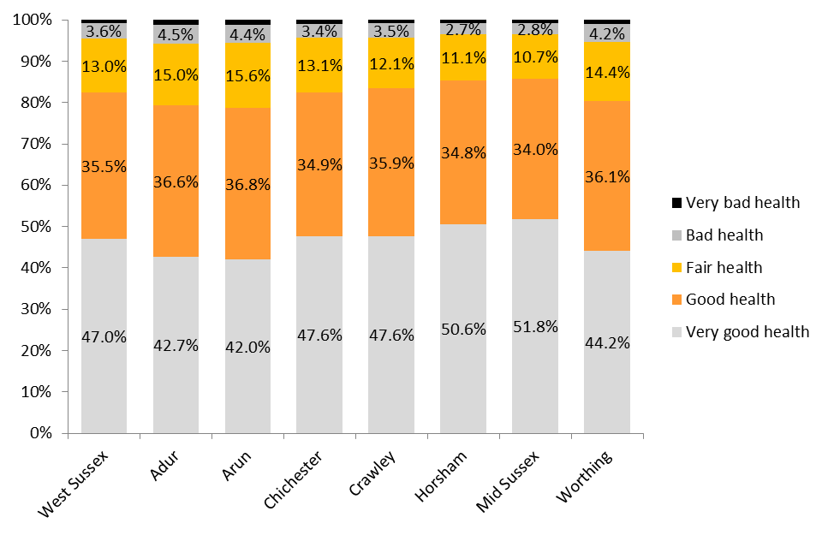

Source: 2011 Census

- Provision of unpaid care

More than 10% of the population in West Sussex provide unpaid care on a weekly basis. There were significantly more people in Adur and Arun that were providing 50 or more hours of unpaid care a week than the West Sussex average while there were significantly less people providing less care in Horsham and Mid Sussex.

Table 12 Provision of unpaid care by number of hours and district

 | Total population | Provides 1 to 19 Hours Unpaid Care a Week | Provides 20 to 49 Hours Unpaid Care a Week | Provides 50 or More Hours Unpaid Care a Week
Adur | 61,182 | 4,472 | 835 | 1,642
% total population |  | 7.3% | 1.4% | 2.7%
Arun | 149,518 | 10,771 | 1,976 | 3,807
% total population |  | 7.2% | 1.3% | 2.5%
Chichester | 113,794 | 8,924 | 1,195 | 2,368
% total population |  | 7.8% | 1.1% | 2.1%
Crawley | 106,597 | 6,378 | 1,418 | 2,106
% total population |  | 6.0% | 1.3% | 2.0%
Horsham | 131,301 | 10,133 | 1,233 | 2,276
% total population |  | 7.7% | 0.9% | 1.7%
Mid Sussex | 139,860 | 10,375 | 1,306 | 2,301
% total population |  | 7.4% | 0.9% | 1.6%
Worthing | 104,640 | 7,268 | 1,319 | 2,292
% total population |  | 6.9% | 1.3% | 2.2%
West Sussex | 806,892 | 58,321 | 9,282 | 16,792
% total population |  | 7.2% | 1.2% | 2.1%

Significantly higher than West Sussex
Significantly lower than West Sussex

Source: 2011 Census

Protected Characteristics – RACE

There are three questions relating to race in the 2011 Census. These are ethnic background, national identity and language. National identity and language were included for the first time in 2011.

The following tables/figures present how these three topics are represented in West Sussex.

Table 13 Ethnic background of residents (%)

 | White British | White Other | Mixed | Asian: Indian/ Pakistani/ Bangladeshi | Chinese | Asian Other | Black | Other Ethnic Groups
West Sussex | 88.9 | 4.8 | 1.6 | 2.1 | 0.4 | 1.0 | 1.0 | 0.3
Adur | 92.9 | 3.0 | 1.4 | 0.9 | 0.4 | 0.4 | 0.5 | 0.5
Arun | 91.6 | 5.4 | 1.0 | 0.6 | 0.3 | 0.5 | 0.3 | 0.1
Chichester | 93.0 | 4.0 | 0.9 | 0.5 | 0.3 | 0.6 | 0.5 | 0.2
Crawley | 72.1 | 7.8 | 2.9 | 9.9 | 0.5 | 2.6 | 3.2 | 1.0
Horsham | 92.2 | 3.9 | 1.4 | 0.9 | 0.4 | 0.8 | 0.4 | 0.2
Mid Sussex | 90.3 | 4.8 | 1.5 | 1.4 | 0.4 | 0.9 | 0.5 | 0.3
Worthing | 89.4 | 4.4 | 1.7 | 1.4 | 0.5 | 1.3 | 0.9 | 0.4
Source: 2011 Census

Between 2001 and 2011, the percentage of people from BME ethnic backgrounds has increased in all districts in West Sussex. Adur followed by Crawley experienced the highest increase in BME groups over that period.

Crawley has the highest percentage of BME groups (27.9%) while Adur and Chichester has the smallest percentages (7.1% and 7.0% respectively).

Figure 4 Percentage BME population in 2001 and 2011 at district level

Source: 2011 Census
National identity

National identity is a self-reported assessment of a person’s affiliation to a country and is therefore not dependent on legal nationality or ethnic groups

Table 14 National identity of residents in West Sussex (%)

 | West Sussex | Adur | Arun | Chichester | Crawley | Horsham | Mid Sussex | Worthing
English | 75.3% | 79.5% | 78.3% | 77.0% | 65.0% | 76.4% | 74.9% | 75.9%
Welsh | 0.8% | 0.7% | 0.7% | 0.9% | 0.6% | 0.8% | 0.8% | 0.7%
Scotland | 1.1% | 0.8% | 1.0% | 1.2% | 1.0% | 1.2% | 1.2% | 1.0%
Northern Ireland | 0.2% | 0.2% | 0.2% | 0.2% | 0.2% | 0.2% | 0.2% | 0.2%
British | 28.1% | 26.6% | 24.8% | 28.0% | 30.1% | 29.5% | 29.8% | 27.9%
Other | 5.7% | 3.0% | 5.6% | 4.1% | 12.0% | 4.1% | 5.2% | 5.3%
*Percentages may not add up as respondents could tick more than one option
Source: 2011 Census

Crawley has the lowest percentage of people identifying themselves as English at 65% while Adur has the highest percentage at 79.5%.

Languages spoken

The question used in the 2011 Census was:

What is your main language?
- English
- Other (write in, includes British sign language)

Table 15 Main languages spoken in West Sussex (%)

Languages | West Sussex | Adur | Arun | Chichester | Crawley | Horsham | Mid Sussex | Worthing
English | 95.3 | 97.6 | 95.4 | 97.2 | 86.9 | 97.3 | 96.6 | 95.7
European | 4.4 | 1.9 | 6.4 | 3.1 | 9.1 | 2.7 | 3.2 | 3.6
Asian | 3.3 | 1.6 | 1.4 | 1.5 | 11.5 | 1.8 | 2.5 | 3.4
African | 0.3 | 0.1 | 0.2 | 0.2 | 1.2 | 0.2 | 0.2 | 0.4
Other languages | 0.6 | 0.5 | 0.4 | 0.2 | 2.1 | 0.2 | 0.3 | 0.5
Source: 2011 Census

More than 95% of residents in West Sussex reported that their main language is English. Similar to national identity, Crawley has the lowest percentage of people who state that English is their main language and the highest percentage of residents who speak Asian languages. At 6.4%, Adur has the highest percentage of people speaking European language
Protected Characteristics – RELIGION

The data below were taken from the 2011 Census. The main religion was Christianity at 61.8%, 26.9% of people stating they did not have a religion.

Table 16 Main religious groups in West Sussex (%)

 | Christian | Buddhist | Hindu | Jewish | Muslim | Sikh | Other religion | No religion
West Sussex | 61.8 | 0.4 | 0.9 | 0.2 | 1.6 | 0.1 | 0.5 | 26.9
Adur | 58.6 | 0.3 | 0.2 | 0.4 | 1.0 | 0.0 | 0.6 | 31.3
Arun | 65.3 | 0.3 | 0.2 | 0.2 | 0.5 | 0.0 | 0.5 | 25.3
Chichester | 66.1 | 0.4 | 0.2 | 0.1 | 0.4 | 0.0 | 0.5 | 24.6
Crawley | 54.2 | 0.4 | 4.6 | 0.1 | 7.2 | 0.7 | 0.4 | 26.0
Horsham | 63.5 | 0.3 | 0.3 | 0.2 | 0.5 | 0.1 | 0.4 | 26.9
Mid Sussex | 62.7 | 0.4 | 0.6 | 0.2 | 0.8 | 0.1 | 0.7 | 26.6
Worthing | 58.1 | 0.6 | 0.5 | 0.2 | 1.3 | 0.1 | 0.6 | 30.2
Source: 2011 Census

Between 2001 and 2011, the percentage of people who stated they were Christians had decreased. This is coupled by an increase in people of in other religions as well as those reporting not having a religion.

Figure 5 Comparison of people stating their religious groups in 2001 and 2011 (%)

*All other religion includes Buddhist, Hindu, Jewish, Muslim and Sikhs.
Source: 2011 Census
Protected Characteristics – MARRIAGE AND CIVIL PARTNERSHIP

In 2011, there were 335,230 (50.6%) married people in West Sussex. This is higher than the South East or England overall.

For the first time, the Census question on marital status includes civil partnership status; 0.2% of the population aged 16 years and over were in a civil partnership.

The percentage of people who were divorced or formerly in a same-sex civil partnership (as a proportion of the population aged 16 and over) was also higher than the South East or national figures.

Table 17 Marital status of residents aged 16 years and over (%)

 | Single | Married | In a registered same-sex civil partnership | Separated but legally married/in a same-sex civil partnership | Divorced or formerly in a same-sex civil partnership | Widowed/ Surviving partner from a same-sex civil partnership
ENGLAND | 34.6 | 46.6 | 0.2 | 2.7 | 9.0 | 6.9
SOUTH EAST | 31.9 | 49.3 | 0.2 | 2.5 | 9.1 | 6.9
West Sussex | 28.8 | 50.6 | 0.2 | 2.5 | 9.7 | 8.2
Adur | 29.6 | 47.9 | 0.3 | 2.5 | 10.7 | 9.0
Arun | 26.8 | 50.0 | 0.3 | 2.6 | 10.5 | 9.9
Chichester | 27.1 | 52.2 | 0.2 | 2.3 | 9.3 | 8.9
Crawley | 34.7 | 46.7 | 0.2 | 2.8 | 9.3 | 6.3
Horsham | 26.1 | 55.3 | 0.2 | 2.2 | 8.8 | 7.3
Mid Sussex | 28.0 | 53.6 | 0.2 | 2.3 | 8.7 | 7.1
Worthing | 31.5 | 45.7 | 0.3 | 2.8 | 11.2 | 8.5
Source: 2011 Census

Protected Characteristics – SEXUAL ORIENTATION

Summary point:

- Nationally, it is estimated that between 5%-7% of the population are lesbian, gay or bisexual

- The Intergrated Household Survey (IHS) between April 2011 and March 2012 estimate that nationally -

- 93.9% of adults identified themselves as heterosexual/straight
- 1.1% identified themselves as Gay or Lesbian
- 0.4%identified themselves as Bisexual
- 0.3% identified themselves are ‘Other’
- 3.6% stated ‘Don’t know’ or refused to answer the question
- 0.6% stated ‘No response’ to the question

Protected Characteristics – PREGNANCY AND MATERNITY

The table below shows the number of live births and fertility rates for districts in West Sussex.
Live births –number of live births in NHS hospitals
General Fertility Rate (GFR) – Number of live births per 1,000women aged 15-44

Table 18 Number of births and fertility rates at district level

 | Births (2012) | GFR (2011)
Adur | 716 | 65.5
Arun | 1,599 | 65.7
Chichester | 997 | 53.5
Crawley | 1,617 | 68.2
Horsham | 1,268 | 55.8
Mid Sussex | 1,523 | 60.0
Worthing | 1,168 | 60.0
Source: Child Health Bureau(CHB)

