Life Expectancy at Birth in West Sussex 2001-2012
Data Briefing
Key Points
- Life expectancy (LE) figures were calculated for both men and women for West Sussex and constituent districts and for each deprivation decile (tenth) of the county for each 3 year period 2001-2003 to 2010-2012 in order to examine trends over time.
- Life expectancy figures were also calculated at ward level for all persons for two 6 year periods; 2001-2006 and 2007-2012. Due to the low annual number of deaths in small areas, more years need to be pooled in order to generate enough data to calculate ward level life expectancy.
- Life expectancy in West Sussex was 80.5 years for men and 83.9 years for women in 2010-2012 combined, up from 77.7 years and 81.9 years in 2001-2003 combined.
- Life expectancy improved for men and women in every district and borough of West Sussex between these time periods.
- Life expectancy figures for women do not differ significantly by district but figures for men are lower than the West Sussex average in Arun and Worthing and higher in Horsham and Mid Sussex.
- The life expectancy gap between electoral wards has increased from 12.2 years in 2001-06 to 15.1 years in 2007-12 (for wards with higher certainty around the data the differences were 11.7 and 13.2 years) although this change is not statistically significant.
- When combined, proportion of population in care homes and older person poverty accounted for 70% of the difference in life expectancy at ward level. After adjustment for population in care homes, a 5% rise in older person poverty was associated with a 1 year drop in life expectancy.
- Of the wards where life expectancy was significantly different from the West Sussex average (either higher or lower) in 2001-06, 76% remained significantly different in 2007-12.
- The social gradient in life expectancy (the average change associated with a 1 decile shift in deprivation) increased for both men and women between 2001-03 and 2010-12 an indication that while LE improved across the board, health inequalities have been increasing.
- Causes of death have not been examined as part of this briefing.

All data presented in this report are available for download at http://jsna.westsussex.gov.uk/jsna-Core-dataset

Public Health
Research Unit

About Life Expectancy Calculations
Life expectancy at birth is defined as the average number of years a cohort of babies would live if they experienced the age-specific death rates of the prevailing time period throughout their life. For example, life expectancy at birth in 2013 is the average number of years a group of babies born in 2013 would live if they were to experience the age –specific mortality rates of 2013. It is not, therefore, a projection into the future but a measure of the health of the population in the here and now. No data on trends, technological advancements, social class, lifestyle factors, political decisions and so on are used in the calculation; simply the number who died and the number who lived in each age group over a given time period.
An accurate figure for life expectancy requires a lot of data and small variations in deaths year on year can have a big effect on estimates. To counteract this, several years of pooled data are often used in the calculation. For smaller areas such as wards, The PHRU method pools males and females together along with several years’ deaths to try to reduce uncertainty around the estimates for local areas within West Sussex. At larger geographies, such as districts, life expectancy may be calculated separately for males and females.
All data are presented with 95% confidence intervals, which indicate the level of uncertainty around the estimate. If figures for two areas have confidence intervals that overlap with each other, they are not considered to be ‘statistically significantly’ different from one another. In other words, we can’t be sure that life expectancy in one of these areas is really any different from that in the other. If the confidence intervals do not overlap, we would consider that good evidence that there is something different about the health of these two populations.
All death data in this report have been assigned a geographic area based on postcodes contained within the Primary Care Mortality Database. A small proportion of deaths (average 0.1%) did not have a postcode attached and were therefore unable to be analysed. This may result in small discrepancies between this data and other published sources. The population base used as the denominator in the calculations was the ONS revised population estimates at LSOA level for each year.

Life Expectancy at County and District Level
Life expectancy in West Sussex and the county’s constituent districts and boroughs is shown in Table 1. Areas where estimates for men are significantly different from the county average are highlighted red and green. Estimates for women were not significantly different from the county average in any area.
LA | Men (10-12) | CI (95%) | Women (10-12) | CI (95%)
Adur | 80.4 | (79.6 - 81.3) | 83.4 | (82.6 - 84.1)
Arun | 79.7 | (79.1 - 80.2) | 83.5 | (83 - 84)
Chichester | 80.9 | (80.3 - 81.6) | 84.6 | (84 - 85.2)
Crawley | 79.7 | (79 - 80.4) | 83.6 | (82.8 - 84.3)
Horsham | 81.7 | (81.1 - 82.3) | 84.4 | (83.8 - 85)
Mid Sussex | 81.9 | (81.3 - 82.4) | 84.2 | (83.7 - 84.8)
Worthing | 78.8 | (78.1 - 79.4) | 83.1 | (82.5 - 83.7)
West Sussex | 80.5 | (80.3 - 80.8) | 83.9 | (83.7 - 84.1)
Table 1 – LE for Males and Females by District 2010-2012

Life expectancy has risen steadily for both males and females in all of West Sussex’s districts and boroughs between 2001-2003 and 2010-2012. The Y axis does not start from zero or include confidence intervals to enable easier identification of trends.

Figure 1 – Life expectancy at birth 2001-03 to 2010-12 by LA (Males)

Figure 2 – Life Expectancy at birth 2001-03 to 2010-12 by LA (Females)
Table 2 shows that male and female life expectancy increased in every district between 2001-03 and 2010-1. Estimates are quite volatile year on year (seen in Figures 1 and 2); any differences observed in the increases between districts are not considered statistically significant.
Change 2001-03 to 2010-12 | Change in Male LE | Change in Female LE
West Sussex | 2.8 | 2.0
Adur | 3.1 | 0.9
Arun | 2.2 | 1.7
Chichester | 3.1 | 2.3
Crawley | 1.1 | 2.7
Horsham | 3.1 | 1.6
Mid Sussex | 4.2 | 1.7
Worthing | 2.4 | 2.0
Table 2 – Total change in LE by district 2001-03 to 2010-12

The Social Gradient of Life Expectancy
Life expectancy has been found to be associated with deprivation and social gradients (the average change in life expectancy with each successive decile of deprivation) at county level are routinely published by Public Health England (termed the Slope Index of Inequality or SII). We have replicated these calculations for both males and females at three year time periods to assess whether the gradient has changed. A steeper gradient (a higher value) indicates greater social inequality.
In 2010-12, men in the least deprived tenth of the county were living 8.8 years longer than men in the most deprived tenth, up from 7.8 years in 2001-03. For women the difference has moved from 4.2 to 7.2 years.
The Slope Index of Inequality increased so that each decile above the most deprived represented an average of 0.69 years of LE for each person in West Sussex in 2010-12, an increase from 0.59 years in 2001-03. This change was largely among women, where the SII increased from 0.45 years to 0.62 years per decile; for men the change was from 0.74 to 0.76 years.

Figure 3 – Slope Index of Inequality in Life Expectancy at Birth in 2001-06 and 2007-12

Despite LE having risen in all districts in West Sussex, inequality in its distribution has therefore increased. This change is considered statistically significant for women and all persons combined but not for men. Results are in Table 3 with significant changes highlighted in red.
 | Years 2001-03 |  |  | Years 2010-12
 | Gradient | LCL | UCL | Gradient | LCL | UCL | Change/Sig
Males | 0.74 | 0.68 | 0.81 | 0.76 | 0.70 | 0.82 | 0.02
Female | 0.45 | 0.39 | 0.50 | 0.62 | 0.57 | 0.68 | 0.17
All Persons | 0.59 | 0.55 | 0.63 | 0.69 | 0.65 | 0.73 | 0.10
Table 3 – Change in LE gradient by deprivation decile between 2001-03 and 2010-12

Life Expectancy at Ward Level
West Sussex has previously been highlighted as the county with the greatest ward level inequalities in life expectancy in the South East region. One of the aims of this report has been to examine how West Sussex’s life expectancy gap might have changed over the last 10 years.
Life expectancy data at ward level is difficult to estimate with any certainty; because of this, data have been aggregated into the six year periods 2001-2006 and 2007-2012.
The life expectancy data for 2007-2012 are shown in ranges in Map 1 (detailed data in the Appendix). The spread of data exhibits a similar pattern to that calculated previously by the PHRU, with low LE in many of the wards along the coast and in the West of Crawley and high LE in many of the wards in the rural centre of the county.
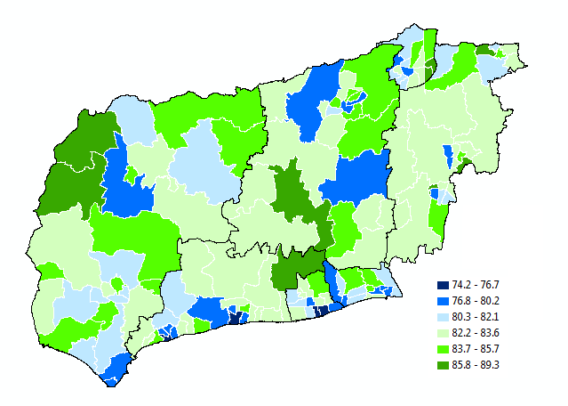
Map 1 – LE by West Sussex Ward (2007-2012)

The five wards with the lowest life expectancies were River and Marine in Arun district, Southgate in Crawley Borough and Heene and Central in Worthing Borough. The five wards with the highest life expectancies were Burgess Hill Dunstall and East Grinstead Imberhorne in Mid Sussex, Findon in Arun, Pound Hill South in Crawley and Harting in Chichester. It should be noted that there were very few deaths in these five wards, meaning estimates carry a high degree of uncertainty. Results are shown in Table 3 (wards significantly higher and lower than the West Sussex average are highlighted green and red respectively).
Highest Wards | LE (2007-12) | 95% CI | Lowest Wards | LE (2007-12) | 95% CI
Burgess Hill Dunstall | 89.3 | (84.3 - 94.4) | Southgate | 78.0 | (76.9 - 79.1)
East Grinstead Imberhorne | 87.5 | (85.1 - 89.8) | Central | 76.7 | (75.6 - 77.9)
Findon | 87.4 | (85.1 - 89.7) | Heene | 75.2 | (73.9 - 76.5)
Pound Hill South and Worth | 86.6 | (84.4 - 88.9) | Marine | 74.5 | (73 - 75.9)
Harting | 86.6 | (84.1 - 89.1) | River | 74.2 | (72.8 - 75.6)
Table 4 – Highest and Lowest Ward Level Life Expectancies 2007-12
Factoring out wards in which very few deaths occurred (standard error > 1), the absolute difference in life expectancy at ward level was 11.7 years in 2001-2006 and 13.2 years in 2007-2012 (this change is not statistically significant).
Map 2 shows the wards which had life expectancies significantly above or below the West Sussex average in both time periods. Of the 58 wards that were significantly different from the West Sussex average in 2001-06, 76% (44) remained significantly different in 2007-12.
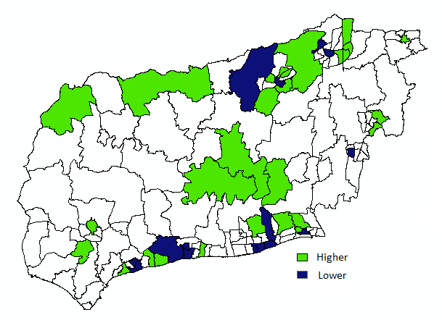
Map 2 – Wards that were significantly different from the West Sussex average in both periods (2001-06, 2007-12)

There were 20 wards in West Sussex in which LE increased significantly between the two periods and none where it decreased significantly. These wards are shown in Map 3.
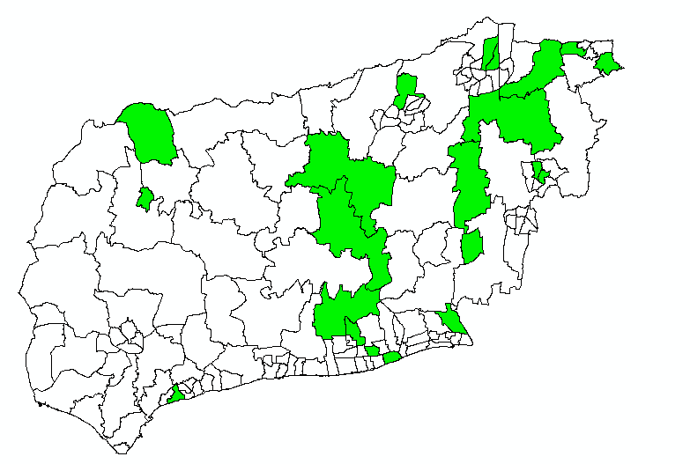
Map 3 – Wards where LE significantly increased (2001-06, 2007-12)

Despite pooling six years of estimates, there were still areas where there were very few deaths. These areas have a high degree of uncertainty around their Life Expectancy estimate and are highlighted in Map 4. They are particularly concentrated in rural areas with smaller numbers of residents.
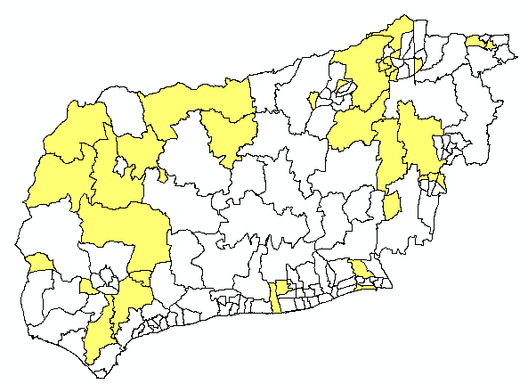
Map 4 – Wards where estimates have a large confidence interval (2007-12)
Many wards were also found to be significantly different from the district in which they are located. These are shown in Map 5.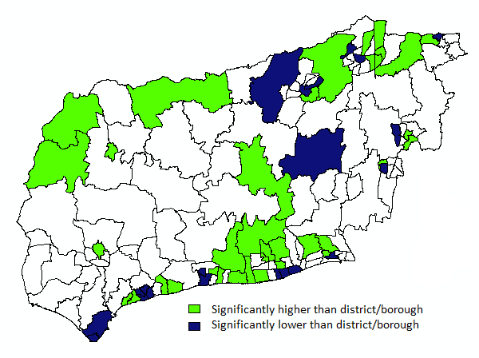
Map 5 – Wards where estimates were significantly higher or lower than their district average (2007-12)
Determinants of Life Expectancy at a Local Level
Regression analysis is a method of determining how the change in one or more variables relates to the change in another. We built several regression models to examine how variables such as income, poverty, population composition and rurality were related to ward level life expectancy in 2007-12.
Life expectancy was found to be fairly well correlated between the two time periods, with figures in 2001-06 explaining about 62% of the variation in 2007-12 (p<0.05).
The relationship between life expectancy and several independent variables was also assessed with older person poverty and proportion of population in care homes being found to be the best predictors of LE at ward level.
Assessed Variables | Source | Result (Significance)
Older Person Poverty | IMD 2010 | Significant
Pop in Care Homes | Census 2011 | Significant
Rurality | ONS Classification | Not Significant
District/Borough | ONS Classification | Not Significant
% of population aged 65+ | Census 2011 | Not Significant
LNIA Status | Local Classification | Not Significant
Mean Income | CACI Model | Not Significant
Table 5 – List of Variables Assessed as Potentially related to Ward Level Life Expectancy (2007-2012)
After adjustment for these variables, rurality, district, population structure, Local Neighbourhood Improvement Area (LNIA) status and mean income were not significant (the effect of these last two being better explained by older person poverty).
A 5% increase in older people living in care homes (Census 2011) was associated with a 1 year drop in ward level life expectancy (p <0.05). Similarly a 5% rise in older person poverty (IMD data relating to 2008) was also associated with a 1 year drop in life expectancy (p < 0.05).
Overall population in care homes and older person poverty were found to explain 70% of the variation in life expectancy between wards in 2007-12 (p<0.05). This increased to 76% if wards with higher uncertainty around the LE estimate (SE<1) were excluded and rurality, district, population structure, LNIA status and mean income remained insignificant (p>0.05).
The relationship between older person poverty (IMD data relating to 2001) and ward level LE for the whole of England for the period (1999-2003) was also examined and similarly, a 4% rise in older person poverty was found to be associated with a 1 year drop in LE after adjustment for care home population (Census 2001) (p<0.05).

A ‘life table’ method – suitability discussed in Williams et al 2005 - http://www.sepho.org.uk/viewResource.aspx?id=9847
ONS data available at time of this publication – 2001, 2002-2010, 2011 and 2012
A note on validation – our data for 2009-2011 are very similar to those published by Public Health England for 2009-2011 http://www.lho.org.uk/LHO_Topics/Analytic_Tools/Segment/Documents/LA_E10000032.pdf
Fair Society Healthy Lives Marmot et al 2010
Calculated from Index of Multiple Deprivation data
APHO Health Profiles http://www.apho.org.uk/default.aspx?QN=P_HEALTH_PROFILES
Statistical Note – modelling gradient change is complex. Use of typical OLS regression results in significance being highly biased by number of data points. It was decided to test the significance of the gradient change by calculating confidence intervals from 1000 resampled values for LE at each decile in each time period. For more information contact JSNA@westsussex.gov.uk
West Sussex Health Inequalities Strategy
West Sussex Ward Profiles 2013 - http://jsna.westsussex.gov.uk/JSNA-Profiles
Standard Error greater than 1 chosen as a largely arbitrary cut off after visual examination of the data
Statistical note - Various modelling methods were used to examine the relationship between LE and the independent variables including GLM with various links and OLS/GLM with log transformed variables and interaction terms. No methods yielded significantly more information than a standard OLS, however (assessed by Bayesian Information Criterion).
This method caused a slight violation of heteroskedasticity assumptions but this was determined to be through small sample size being biased by statistical outliers rather than a misspecification of the model.

